Project name: One Plus mobile shopping site

- First created a database name oneplus.
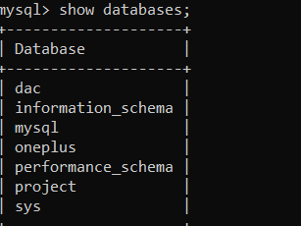
- Then Created the following tables;
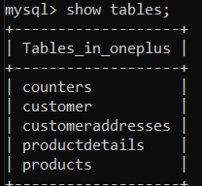
- Then in the “products” table added the products;
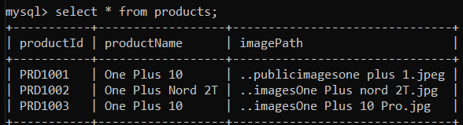
- Created the backend application for the project;
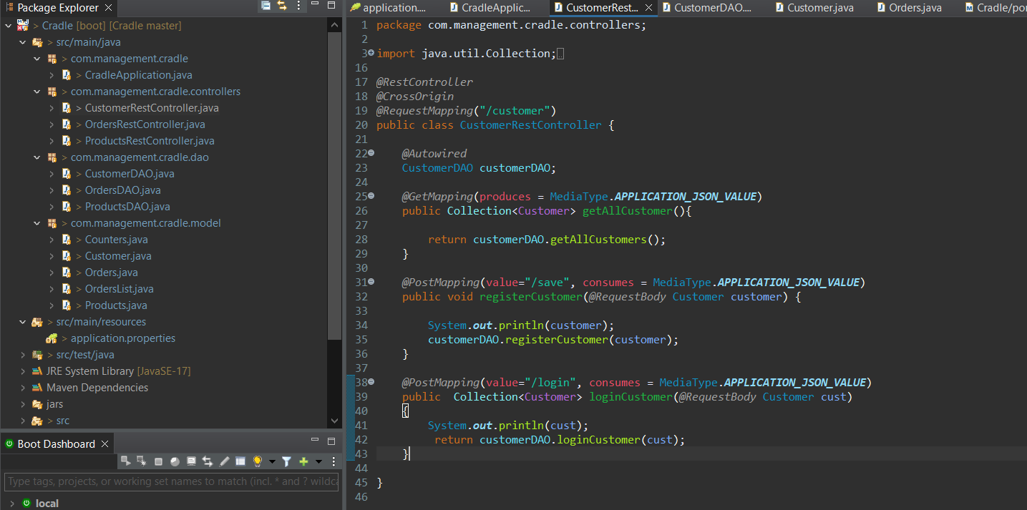
Made the backend application following a 3 layer architecture using spring mvc.
The working goes from service layer to dao layer and then the controllers.
Service layer has all the business logic ,dao layer allows us to isolate the application layer from the persistence layer.
The data goes to service layer first where we have the setter getters the data gets saved and afterwards it goes to the database.
- In the front end I have made 6 components.

- login page

- signup page
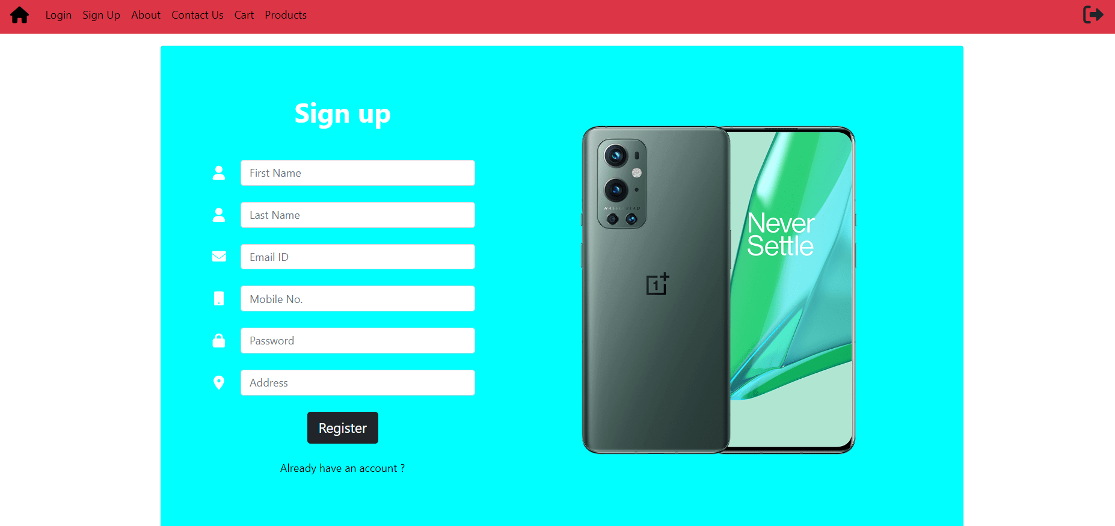

- Contact Us
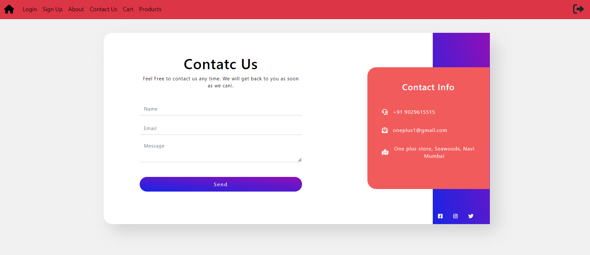

- Products ,cart and about us.

